1 This project involves using the GPIO pins on the Raspberry to control the speed of a motor (in a Slot car). This requires the use of a voltage regulator to convert the +5V output of the Raspberry GPIO pin to a 12V signal. Using a PWM GPIO pin as the control we can alter the speed of the slot car by regulating the voltage between 0 and 12V.

The purpose of this Project is to create a circuit to control the slot car and then to use a program (Scratch) to control the car as it proceeds around the track.

! This involves creating electrical circuits and connections. We recommend this is done under the guidance of a mentor or parent.

2 You will need to have a voltage regulator such as this:

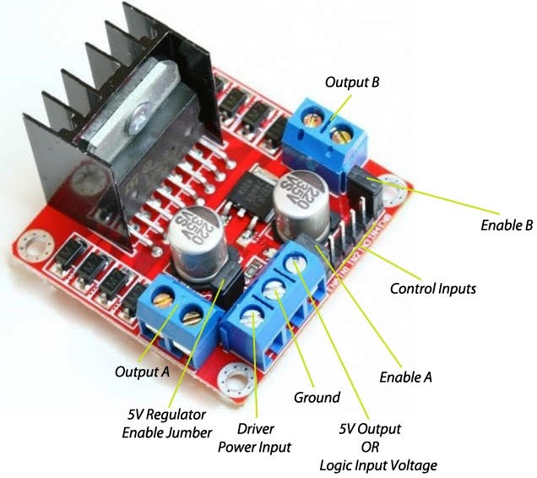

4 The Slot car track may work by providing power to both rails. Usually the circuit is interrupted by the hand controller which acts as a potentiometer, increasing the voltage from 0 to 12V as the trigger is squeezed, and of course the motor is housed in the car connected to the track with wire brushes.

In this project we can use the Voltage regulator to simulate the same behaviour. By default power is fed to both tracks when supplied through the regular power port on the track connections. When power is supplied through this connection both cars will be fed with the same voltage.

If you want to have independent lanes (one managed by the Computer and one by the Hand controller), you will have to break this circuit by simply soldering some wires to the track and providing a 12V (or regulated) feed directly to the track via the voltage regulator and stopping the 12V feed from the supply going into the track connector (a change you can make by unscrewing the back plate from the back of the track where the supply is provided.

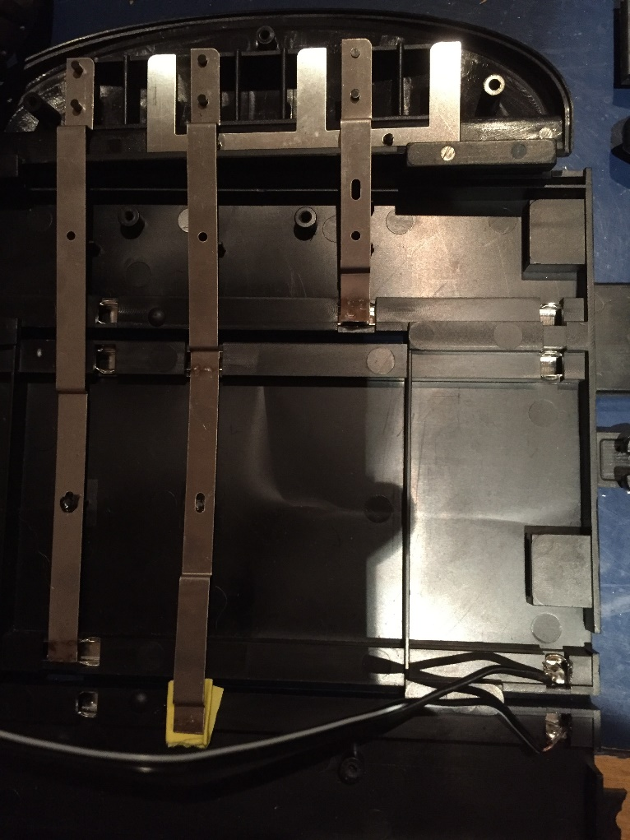

1. Interrupted normal supply to inside track from shared supply socket
2. Soldered wires to allow for the supply from the regulator attached to the Pi

Note: Here white and black is the 12V supply wire. Black is ground

5 Then you will need to wire up your slot car track according to this circuit

s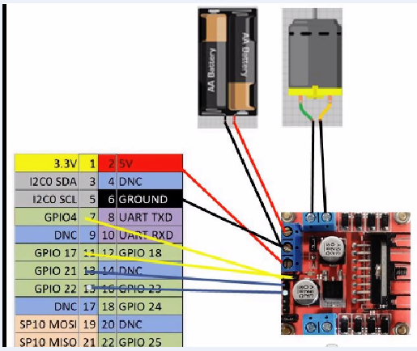

15V (Slot car mains adapter) External Power

To Power on the track (wires soldered to the rails in previous picture (the motor is in the car and will take its power from the rails)

You will need to common the GND between the controller and the Pi hence the BLACK wire connected to pin 6.  
  
if you are using a supply voltage greater than 12 V DC,  remove 5V Regulator Enable jumper unless you plan to power the Pi from this.

<http://tronixlabs.com/news/tutorial-l298n-dual-motor-controller-module-2a-and-arduino/>

The blue wires are connected to IN1 & IN2 which control the direction of DC motor connected to Output A. This means that pins 13 (GPIO 21) and 15 (GPIO 22) will control the direction according to the following table.

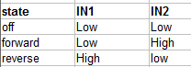

For basic operation leave the**ENABLE A** **jumper** in place and set 2 GPIO pins to control **IN1 & IN2** the car should travel around the track.

For speed control of your motor which is needed (as the car will travel at full speed when supplied with 12V), you will need to remove the **ENABLE A jumper** and connect the **yellow wires** as above. Pin 7 (GPIO 4) & pin 11( GPIO 17) need to be configured as  **PWM**  outputs not just standard output (seems to happen automatically with ScratchGPIO. When wiring this up the pin **nearest the edge** of the regulator board is connected to **pin 11**. The final wiring looks like this.

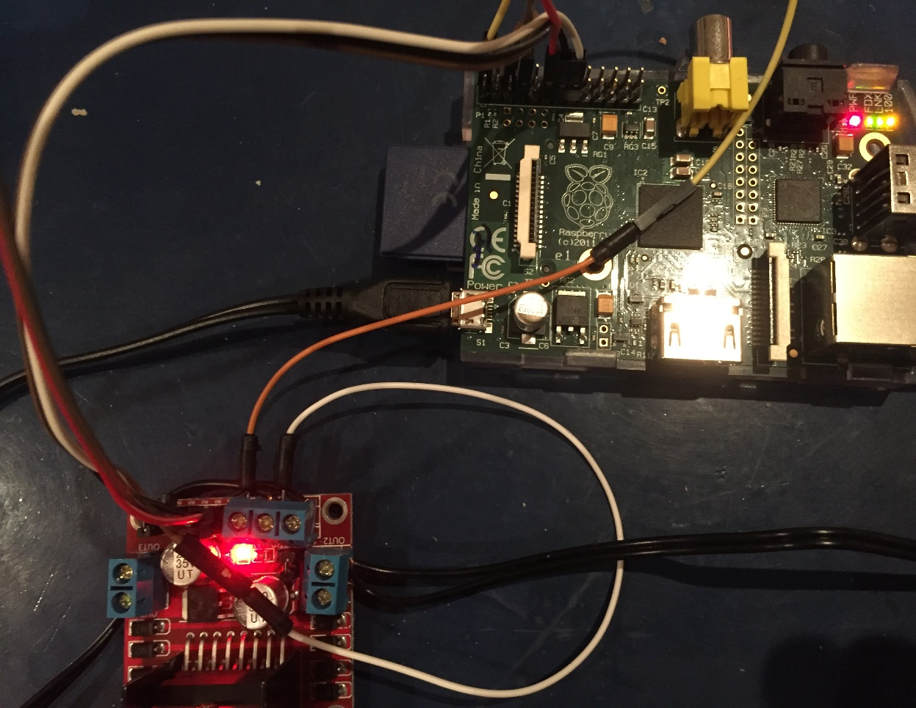

To Pin 2 - 5v

Ground – Pi and Supply

12V Supply

Jumper A outside pin to Pin 11 PWM

Ground

To track

12V to track

Now you have the circuit made you can now start to experiment with controlling the power output on Pin 11 (GPIO 17) to control the speed of your slot car!

6 A simple program written in Scratch can now control the speed of the Slot car. The Jessie distribution has built in GPIO support, the Wheezy distribution will support the same with the ScratchGPIO modification.

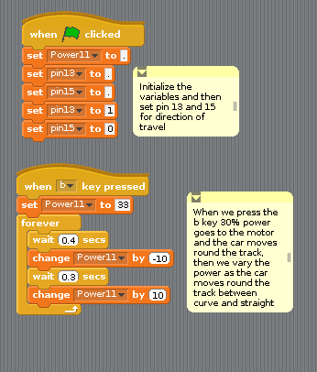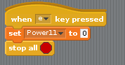

More information on Scratch and GPIO can be found in these resources:

<https://cymplecy.wordpress.com/2013/03/19/scratch-gpio-development/>

<https://www.raspberrypi.org/documentation/usage/scratch/gpio/README.md>